📘 Guide to Using the Blue Courses Notebook

This notebook (_Codetoextract.ipynb) automatically extracts and organizes **course dates and evaluation (SOQ) dates** from the Blue Courses system. The result is a clean Excel file with the start, end, and SOQ windows for each **Part of Term**.

# ✅ What the Notebook Produces

When you run the code, it creates an Excel file named:

NEWSOQCalender.xlsx

* Each row = one **Part of Term** (e.g., "Full Term", "First 8 Weeks").
* Columns included:
  + **Part Of Term**
  + **Course Start Date** (earliest start in that part)
  + **Course End Date** (latest end in that part)
  + **SOQ Start** (earliest evaluation window)
  + **SOQ End** (latest evaluation window)
  + **CourseName** (list of unique courses in that part)

This Excel file can then be easily converted into Word or PDF (as you’ve been doing for Winter, Spring/Summer, and Fall semesters).

# 🖥️ How to Run the Notebook

1. **Open Jupyter Notebook** on your computer. (I use anaconda) or Visual Studio
2. Navigate to the file _Codetoextract.ipynb.
3. Run the second cell (press **Shift + Enter**) to see the number of POT per semester, this is helpful to know if there are any added pot new ones

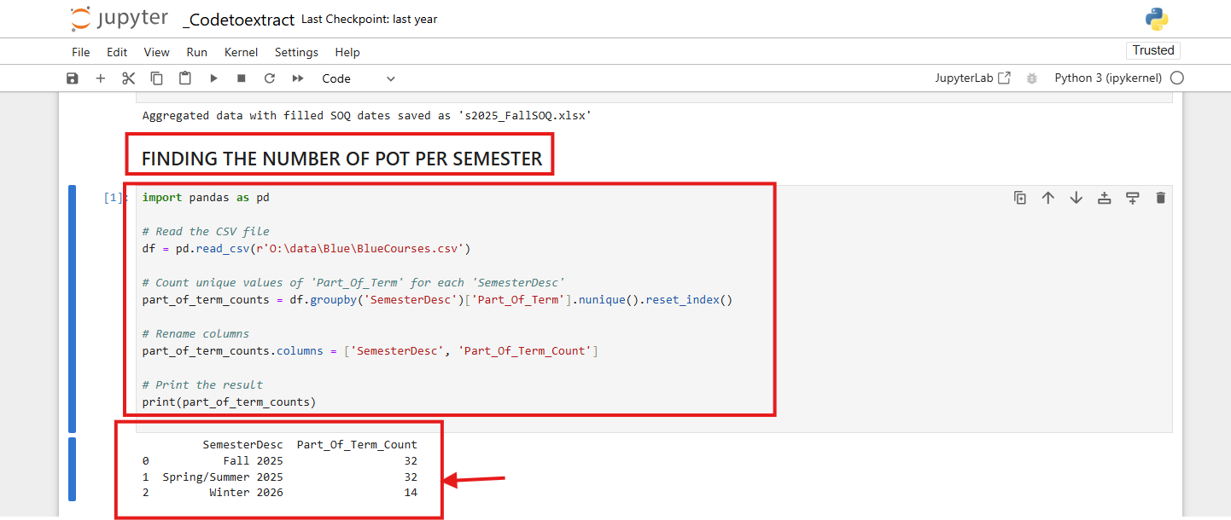

1. To get the CSV file, use the first Cell, but first change to desired semester

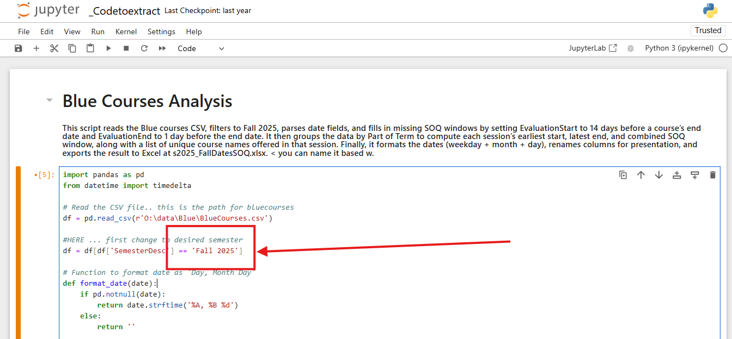

Run the code (press **Shift + Enter**) after changing the semester

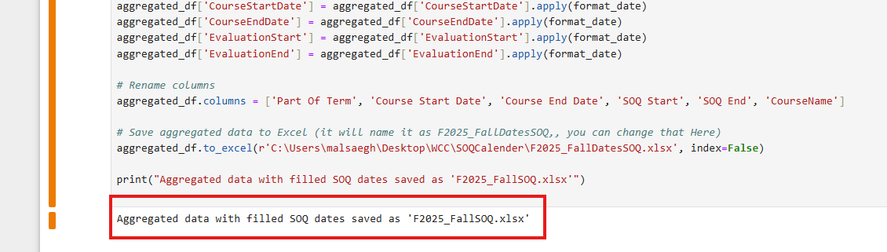

Check your folder … New csv created

1. Copy the rows to the Word file we have and then export it as PDF
2. We upload the PDF to your google drive and get the link and each semester we update to a new version
3. Updating the Drive link.. (this link is used in Blue emails / fillouts/ SM/ and reports or welcoming page)

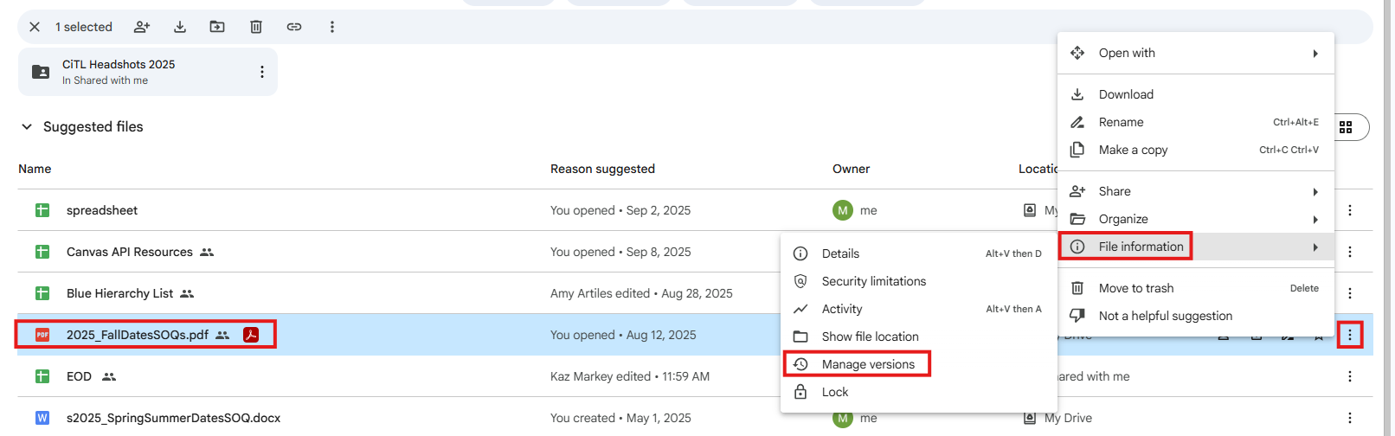

Make sure to update the link in these email templates if you change the link  
Sample: 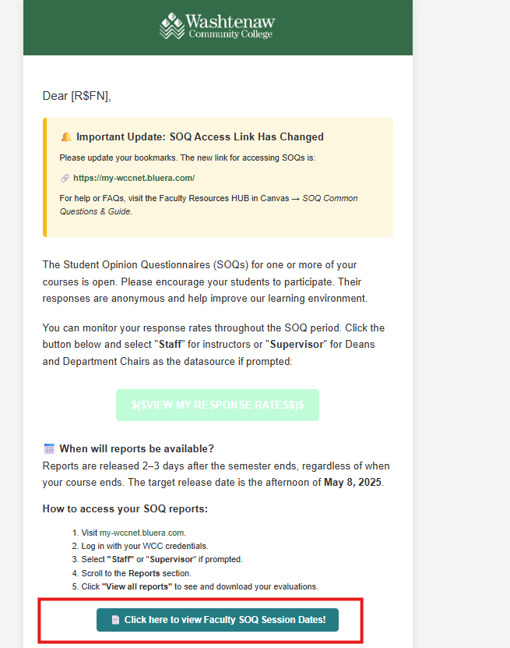 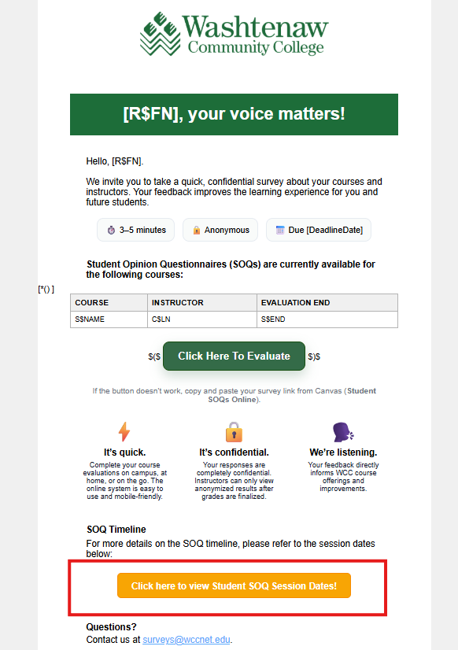

SOQ dates in Canvas

: [CiTL Faculty Resource Hub](https://wccnet.instructure.com/courses/11534) > [SOQ](https://wccnet.instructure.com/courses/11534/pages/soq-common-questions-and-guide)

As well as the Dean Hub

Update this schedule

